Alma Chen

March 15, 2015

Stat 133 Sec 202

BML Simulation Study

The BML Simulation Study

**Introduction:** I tested my BML simulation on three squares of different sizes—a 10x10, 20x20 and 50x50 grid. I let each individual simulation run for 1000 steps and concluded that it is free flowing if no gridlock occurred within the first 1000 steps. Then, I picked 6 density values – 0.3, 0.4, 0.5, 0.7, 0.8, 0.9— and ran 1000 simulations per each of the three sizes per density and found the average number of timesteps till gridlock, the percentage of simulations that ended in gridlock, and the percentage of simulations that ended in free flowing traffic.

**Problem 1**: With a 0.3 density, all simulations on all three matrix sizes produced free flowing traffic. With a density of 0.7, none of the 20x20 and 50x50 matrices resulted in free flowing traffic after 1000 timesteps, while a mere 0.2% of simulations of the 10x10 matrix produced free flowing traffic. At 0.8 and 0.9 density, all simulations on all three matrix sizes produced 100% gridlock. Between 0.3 and 0.7 density, there is a mixture of jams and free flowing traffic.

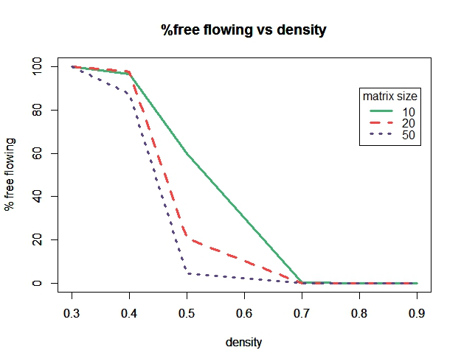

**Figure 1**

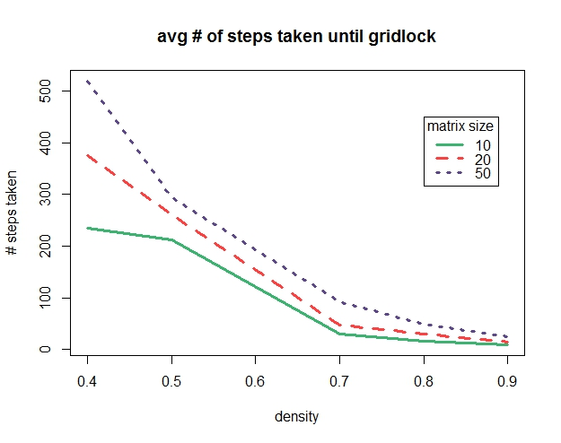

**Figure 2**

**Problem 2**: The number of simulation steps ran before achieving gridlock depended vastly on the density and sizes of the matrices. Because a density of 0.3 never resulted in gridlock, it was not included as a data point in comparing the relationship between steps taken and density. Of the cases with 0.4 density that resulted in gridlock, the average number of steps taken until gridlock ranges from approximately 200 to 500, depending on the size of the matrix. As density increased, the average number of steps taken until gridlock decreases. When density was 0.8-0.9, matrices of all three sizes reach gridlock with an average of fewer than 100 steps. (*Figure 2*)

**Problem 3:** Transition definitely depended on the size of the grid. A smaller matrix size results in a larger percent of free flowing traffic and more steps taken until gridlock is achieved. For example, *Figure 1* shows that 0.5 density, approximately 60% of matrices with size 10x10 are free flowing, whereas approximately 5% of matrices with size 50x50 are free flowing. A smaller matrix size also results in a fewer number of steps taken until gridlock. *Figure 3* illustrates that the average number of steps taken until gridlock is fewer for a matrix sized 10x10 than it is for a matrix sized 50x50.

Transition also depended on the shape of the grid. A 20x20 grid has 400 spaces, and these 400 spaces can be rearranged to create grids of size 16x25, 10x40, and 5x80. As the length to width ratio of these grids increased given constant density 0.6, so did the percentage of grids that have free-flowing traffic. In other words, a more rectangular grid causes fewer traffic jams than a square grid (*Figure 3 on next page*). Also, a more rectangular grid gives a higher number of timesteps elapsed until gridlock is achieved (*Figure 4 on next page*).

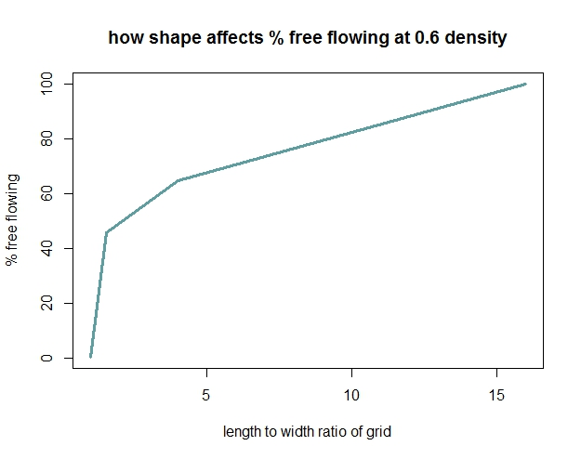

**Figure 3**

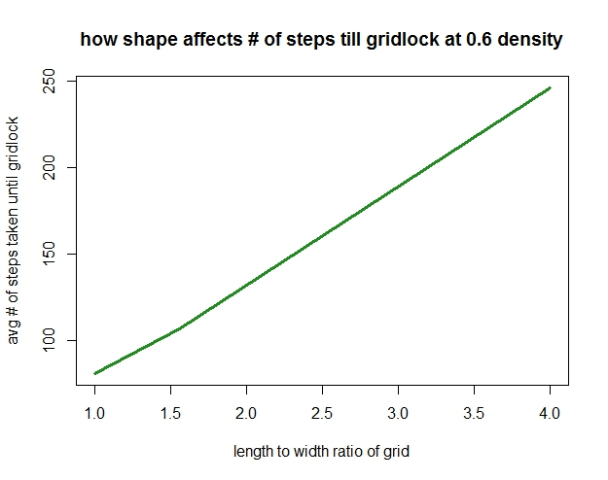

**Figure 4 (The 5x80 grid was not included because 99.7% of samples resulted in free flowing traffic)**